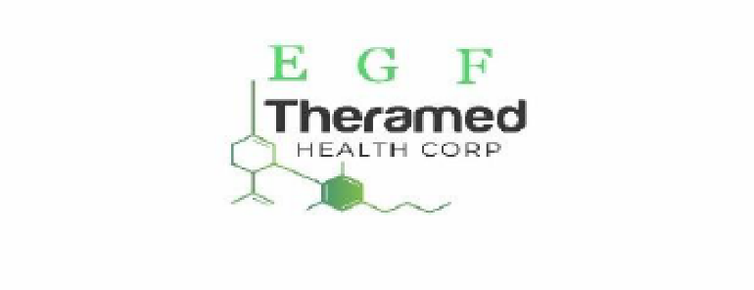
EGF THERAMED LOOKING TO ACQUIRE RETAIL CANNABIS ASSETS

Vancouver, BC, November 2nd, 2022 – EGF Theramed Health Corp. (CSE:TMED / OTC:EVAHF / FRANKFURT: AUHP) (the “Company” of “EGF”) has begun to look into the acquisition of overleveraged retail cannabis assets across Canada and the United States. The ideal target asset will be cash flow positive dispensaries that are located in densely populated areas with high demand for adult recreational cannabis use. As the market has become ever competitive many dispensaries have become leveraged presenting ideal acquisition targets that can be obtained at a fraction of their true value and potential.
“EGF Theramed sits in a strong position to raise capital and further develop quality assets with its experienced management team. Currently we feel there is a significant gap in the value of retail cannabis assets in the market today. The companies that are in a strong cash position will effectively be able to take advantage of this significant market and we plan to be a major player in this sector as most significant cost have been absorbed by predeceasing companies.” States Connor Yuen CEO
EGF Theramed is looking for specific dispensaries that are specially designed to convert and attract customers into the local legal cannabis market. The Company is focused on developing a retail experience that has a specific Cannabis culture and conveys a community feel. The Company expects to offer a wide breadth of products and to elevate the customer experience. The company is targeting prime real estate for consumer accessibility and to help execute the company's long-term vision.
The Canadian Cannabis Retail Market continues to be fragmented and with operators of single retail locations becoming increasingly leveraged. By using its $10 million loan EGF plans to acquire distressed locations and use economics of scale to maximize the conglomerate's value. The size of the legal adult-use cannabis market in Canada stands at $5.43 billion Canadian dollars in 2022. By 2026, this market is forecast to reach $10.44 billion dollars. The market will continue to grow at an accelerated pace giving EGF substantial room for growth with its potential retail assets.
In addition, the company will look at potential partnerships with farm-to-gate operations to setup retail operations on their behalf, allowing them to continue to operate in core production business, while EGF runs the retail operations for a portion of the overall profit.
ABOUT EGF THERAMED HEALTH CORP.
(CSE:TMED / OTC:EVAHF / FRANKFURT: AUHP)

EGF is a consumer technology company engaged in the provision of biomedical online services for monitoring and treating common health problems. The Company, through its subsidiaries, has assets and technologies used in the extraction and purification of botanical extracts and the creation of extract formulations, as well as medical monitoring device technology. The Company is working to collaborate with other companies for medical technology, equipment protocols and laboratory SOPs.
For more information please contact:
EGF THERAMED HEALTH CORP.
Doug McFaul
Email: dmcfaul@emprisecapital.com
Telephone: (778) 331 8505
Website http://www.theramedhealthcorp.com
CSE Micro-site: http://thecse.com/en/listings/technology/Theramed-Health-Corporation
US OTC Markets (OTCQB): http://www.otcmarkets.com/stock/EVAHF/news
Frankfurt Borse: (add link)

CAUTIONARY LANGUAGE
All statements in this press release, other than statements of historical fact, are “forward-looking information” with respect to the Company within the meaning of applicable securities laws, including with respect to the completion of the Transaction contemplated by the Term Sheet. The Company provides forward-looking statements for the purpose of conveying information about current expectations and plans relating to the future and readers are cautioned that such statements may not be appropriate for other purposes. By its nature, this information is subject to inherent risks and uncertainties that may be general or specific and which give rise to the possibility that expectations, forecasts, predictions, projections or conclusions will not prove to be accurate, that assumptions may not be correct, and that objectives, strategic goals and priorities will not be achieved. These risks and uncertainties include but are not limited those identified and reported in the Company’s public filings under the Company’s SEDAR profile at www.sedar.com. Although the Company has attempted to identify important factors that could cause actual actions, events or results to differ materially from those described in forward-looking information, there may be other factors that cause actions, events or results not to be as anticipated, estimated or intended. There can be no assurance that such information will prove to be accurate as actual results and future events could differ materially from those anticipated in such statements. The Company disclaims any intention or obligation to update or revise any forward-looking information, whether as a result of new information, future events or otherwise unless required by law.

