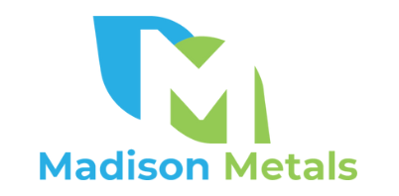
Madison Metals Announces Two New Uranium Anomalies and Provides
Exploration Update on EPL-7011, Namibia

TORONTO, ON – July 11, 2022 – Madison Metals Inc. (“Madison” or the “Company”) (CSE: GREN) is pleased to announce the delineation of two new uranium anomalies at its Rössing North Uranium Project in Namibia, Africa, one of the world’s top uranium-producing countries. Additionally, Madison is making ongoing exploration progress on its Exclusive Prospecting License 7011 (“EPL-7011”), a major untested anomaly adjacent to the Rössing Uranium Mine in the renowned Erongo uranium province of Namibia.

“These very encouraging results have confirmed the expected high potential of EPL-7011,” said Duane Parnham, Executive Chairman and CEO of Madison Metals. “Our team expects to plan drilling of the anomalies to further define the potential for a major uranium deposit on Madison’s Rössing North Project.”

Airborne radiometric data acquired from the Namibian Ministry of Mines and Energy indicated high uranium with low thorium values over Madison’s exclusive licence area. Exploration activities to date have focused on field validation of the uranium anomalies via a systematic ground radiometric and geological survey. The field validation confirms the presence of uranium anomalous sheeted alaskites intruding the Khan Formation, which is overlain by the Rössing formation.

EPL-7011

In June 2022, the Namibian Ministry of Mines and Energy approved the transfer of EPL-7011 to Pennyworth PTY, which is majority-owned by Madison (85%), with Namibian partners holding 15%. EPL-7011 and EPL-8513, whose transfer is in progress, make up Madison’s Rössing North Uranium Project.

EPL-7011 covers a total area of 26.13 km² and is located immediately west of the 3.5-kilometre-long Rössing Uranium Mine (Figure 1). The largely underexplored EPL contains units of the Damara Supergroup represented by the Khan, Rössing, Chuos, Arandis and Karibib Formations. Sheeted alaskites intrude into the Khan Formation, which is a favourable stratigraphic setting for Rössing-type deposits in the Central Namib. A series of synforms and antiforms, including isoclinal folding, also occur over the licence area.

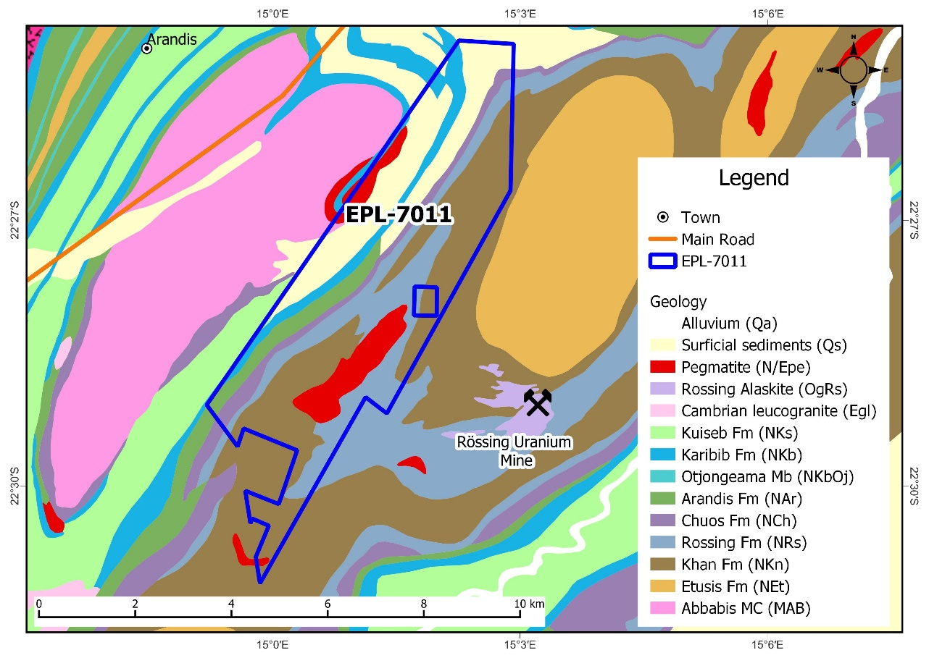
Figure 1: Geology of EPL-7011.

Ground Radiometric and Geological Survey

The survey was conducted over a line spacing of 80 metres (m) and station spacing of 10 m across the airborne radiometric anomalies in the area (Figure 2). The anomaly discovered in the SE portion of the EPL can be split into two: the south-westernmost anomaly and the north-easternmost anomaly (Figure 3). Both anomalies share the same type of lithologies, style of mineralization and structural setting. The lithologies in the area have a general north-east strike and steeply dip towards the south-east. The alaskites occur within isoclinal folding closures close to the Khan-Rössing Formation boundary. The radiometric readings from these alaskites vary from 600 to 6,000 counts per second. The ground radiometric surveying shows that the uranium anomaly has a strike extent of 650 m at the south-westernmost anomaly and 3.4 km at the north-easternmost anomaly.

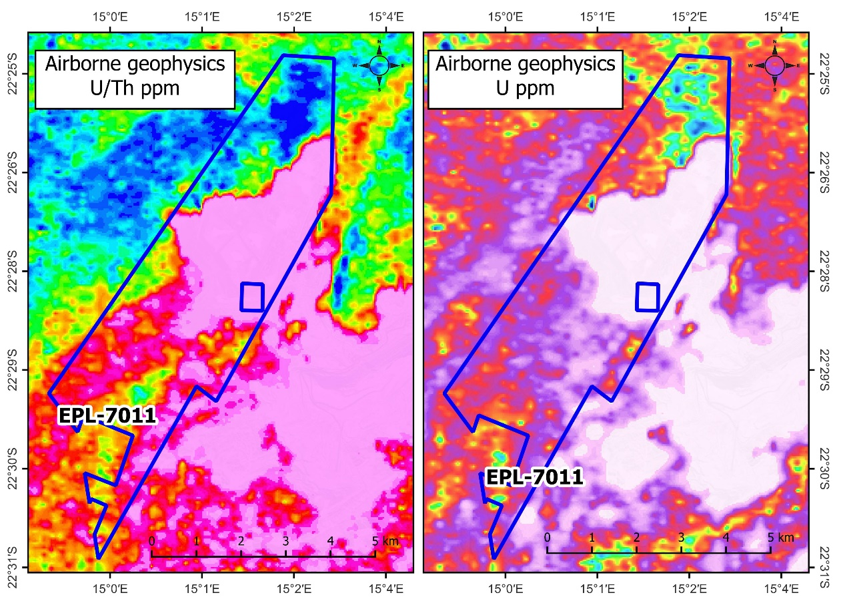
Figure 2: Airborne radiometric signatures (U/Th and U) over EPL-7011.

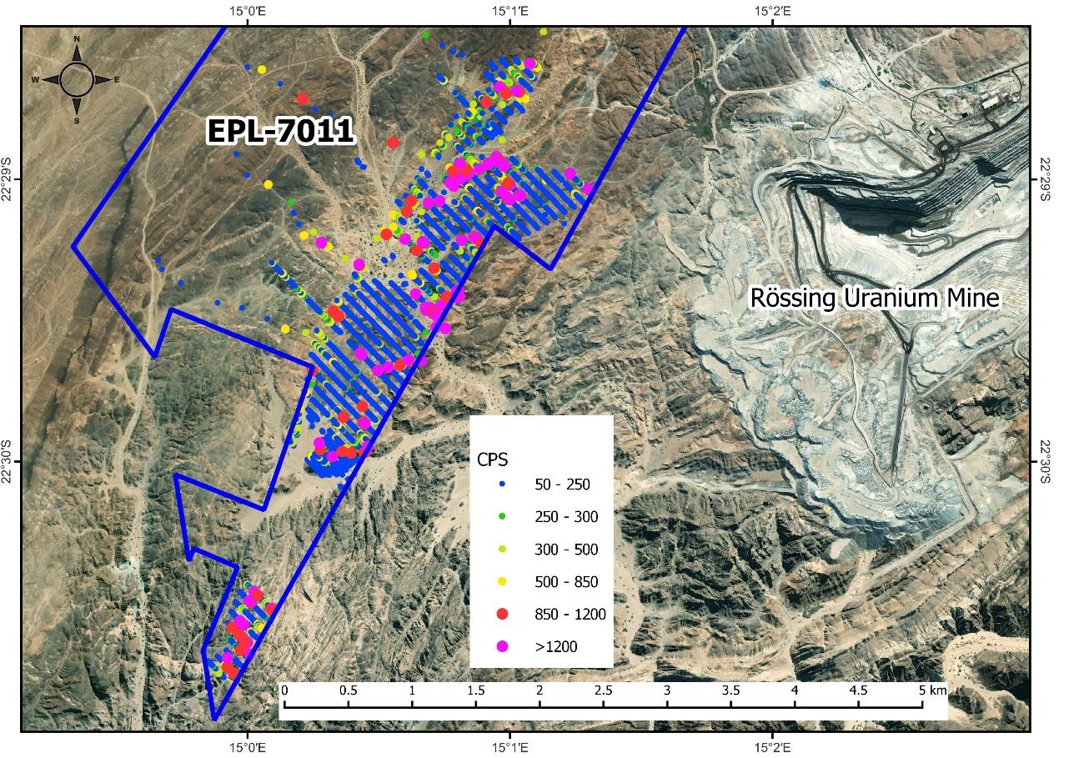
Figure 3: Ground radiometric surveying results from EPL-7011.

The survey over the north-easternmost anomaly could not be extended further towards the north-east due to the Rössing Mine fence. Permission will be required from Rössing to extend the survey further to the north-east.

Qualified Person

Mary Barton, a Professional Natural Scientist (SACNASP) and a Qualified Person for the purposes of National Instrument 43-101 Standards of Disclosure for Mineral Projects for EPL-7011, has reviewed, verified and approved the technical information contained in this news release.

About Madison Metals Inc.

Madison Metals Inc (CSE: GREN) is a green energy resource company with experienced management having particular expertise in the uranium mining industry. Madison’s corporate objective is to build value by advancing Rössing-type deposits identified in Canada and Namibia, Africa by utilizing cutting-edge technology and modern strategies.

Additional information about Madison Metals Inc. can be found at madisonmetals.ca and on the Company’s SEDAR profile at www.sedar.com.

For further information, please contact:

Duane Parnham
Executive Chairman & CEO
Madison Metals Inc.
+1 416.489.0092
ir@madisonmetals.ca

Media:
Adam Bello
Manager, Media & Analyst Relations
Primoris Group Inc.
+1 416.489.0092
media@primorisgroup.com

Neither the CSE nor the Investment Industry Regulatory Organization of Canada accepts responsibility for the adequacy or accuracy of this release.

Forward-looking Statements

This press release contains forward-looking statements. Forward-looking statements involve known and unknown risks, uncertainties and assumptions and accordingly, actual results and future events could differ materially from those expressed or implied in such statements. You are hence cautioned not to place undue reliance on forward-looking statements. All statements other than statements of present or historical fact are forward-looking statements. Forward-looking statements include words or expressions such as “proposed”, “will”, “subject to”, “near future”, “in the event”, “would”, “expect”, “prepared to” and other similar words or expressions. Forward-looking information contained in this press release includes, but is not limited to, the following: the ability of the Company to conduct future exploration at the Rössing North Project, including but not limited to the timing and amount of estimated future exploration; the potential for future exploration to locate uranium deposits; and the development potential and timetable of the Rössing North Project.

Where the Company expresses or implies an expectation or belief as to future events or results, such expectation or belief is based on assumptions made in good faith and believed to have a reasonable basis. Such assumptions include, without limitation, that sufficient capital and other resources will be available to the Company to carry out its operations as currently planned.

Factors that could cause future results or events to differ materially from current expectations expressed or implied by the forward-looking statements include general business, economic, competitive, political and social uncertainties; there being no assurances that the proposed exploration program will yield favourable results; the state of capital markets; the risk that the Company will not receive all necessary approvals required in order to conduct its operations as currently anticipated; accidents, labour disputes and shortages; environmental and other risks of the mining industry; other unforeseen events and developments; factors causing any of the aforesaid expectations, assumptions, and other factors ultimately being inaccurate or irrelevant; and risks associated with the ongoing COVID-19 pandemic.

You can find further information with respect to these and other risks in filings made with the Canadian securities regulatory authorities that are available on the Company’s SEDAR profile page at www.sedar.com. The Company disclaims any obligation to update or revise these forward-looking statements, except as required by applicable law.

