Rockland Resources PREPARES FOR MAIDEN DRILL PROGRAM ON THE Cole Gold MineS Property, West Red Lake, Ontario
Vancouver, British Columbia, April 6, 2021: Rockland Resources Ltd. (the "Company" or "Rockland") (CSE: RKL) has initiated logistic activities and personnel placements directed at the start of a maiden drill program in May, on the newly acquired (see Press Release March 29, 2021) “Cole Gold Mines Property” (Property”), located in Ball Township, Red Lake Mining District.
The current Cole Gold Mines Property consists of 28 mining claims (568 ha) located 30 kilometers west of the Cochenour, Campbell, Red Lake Mine Complex owned and operated by Evolution Mining. The property is being acquired (100%) from Wabassi Resources ULC. (“Wabassi”), whom have an option to acquire the Property from an underlying owner.
The Cole Gold property historically indicated high-grade gold values are associated with sphalerite-chalcopyrite-scheelite-bearing quartz veins in shear and structural zones in porphyry and felsic rocks, striking approximately east-west and dipping steeply to the north. Development work by Cole Gold Mines in the 1930’s included a vertical shaft to a depth of 161.5 metres (530 feet), with four levels established, and over 2,133.6 metres (7,000 feet) of drifting and crosscutting (mostly “on vein”) and 1,219.2 metres (4,000 feet) of underground diamond drilling. Historic (1973) diamond drilling by Kerr Addison Mines has returned values up to 2.2 ounces per ton (oz/ton) gold (68.3 grams per tonne (g/t) gold (Au) over 1.5 feet (ft) (0.46 metre) core width in sulphide mineralized quartz veins.
Company director Mike England reports: “Acquiring a project that is fully permitted and can be advanced quickly (less than 2 months) to a maiden drill program is beneficial to a newly listed exploration company. The Cole Gold Mines Property acquisition represents an under-explored, exciting and strategically located gold property in one of the most active, prolific producing mining districts in Canada. Our proposed drill program will be the first drill program on the indicated gold targets since 1973. The property has historic indications to host high-grade gold values in a classic “Red Lake type” quartz veins and silica-sulphide replacement zones.”
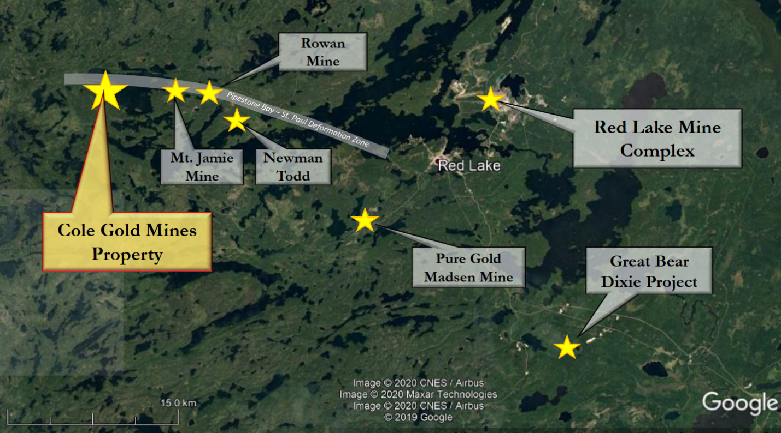
Current activities include:
- A contract proposal for 2,500 meters of HQ diamond drilling has been submitted to established drill contractors in Manitoba and Ontario to mobilize a rig to the Property on, or near, the 3rd week of May.
- A senior consultant geologist has been engaged by the Company to supervise the drill program, with support from the vendor’s (Wabassi) senior geologist, and other Company technical advisors. The site senior geologist is contracted from Planet X Exploration Services Ltd.'s, retained through Grassroots Prospecting. Additional technical and logistical support will be supplied by Clark Exploration Consulting of Thunder Bay.
- The company has also engaged a geophysical contract company to complete an airborne (Drone) high resolution magnetic survey of the property to assist with the geological and structural interpretation. This work is planned during the month of April.
As reported on March 29, 2021, the Property has an approved Exploration Permit PR-20-000368 that is valid until March 3, 2024. The Company will also initiate community consultations, to be conducted under federal and provincial COVID-19 operating protocols and safety measures as required.
Rockland further announces that it has arranged a non-brokered private placement of up to 10 million units ("Units") at a price of $0.20 per Unit for aggregate gross proceeds of $2,000,000.00 (the "Offering"). Each Unit will be comprised of one common share ("Share") and one half of one transferable Share purchase warrant of the Company ("Warrant"). Each whole Warrant will entitle the Subscriber to purchase one Warrant Share for a 24-month period after the Closing Date at an exercise price of $0.30 per share. Net proceeds of the Financing will be used to advance the corporation's Cole Gold Mines project Ball Township, Red Lake Mining District and for general working capital purposes.
Shares issued pursuant to the Financing will be subject to a four-month hold period according to applicable securities laws of Canada.
Finders' fees may be payable on the private placement, subject to the policies of the Canadian Securities Exchange.

The reader is cautioned that historic data and information presented above were completed prior to the implementation of National Instrument 43-101 and must be considered only as a historic reference. Neither the Company nor its Qualified Person have completed sufficient work to verify this historic drill hole, and they should not be relied upon.
Qualified Person
Garry Clark P.Geo., a Qualified Person under National Instrument 43-101, is the Qualified Person responsible for reviewing and approving the technical contents of this news release as they pertain to the Cole Gold Mines Property.
About Rockland Resources Ltd.
Rockland Resources is engaged in the business of mineral exploration and the acquisition of mineral property assets in Canada. Its objective is to locate and develop economic precious and base metal properties of merit and to conduct its exploration program on the properties. In addition to the Cole Gold Property, Rockland is exploring the Summit Old Timer Property that consists of three (3) mineral claims covering an area of 1,915 hectares located approximately 17 km southeast of the City of Nelson, within the Nelson Mining Division, British Columbia.
For more information, please refer to the Company's prospectus dated February 3, 2021 available on SEDAR (www.sedar.com).
On Behalf of the Board of Directors
Mike England
CEO, President and Director
For further information, please contact:
Mike England
Office: 604-683-3995
Email: mike@engcom.ca
Forward-Looking Statements:
This news release includes certain forward-looking statements and forward-looking information (collectively, "forward-looking statements") within the meaning of applicable Canadian securities legislation. All statements, other than statements of historical fact, included herein including, without limitation, statements regarding future capital expenditures, anticipated content, commencement, and cost of exploration programs in respect of the Company's projects and mineral properties, anticipated exploration program results from exploration activities, resources and/or reserves on the Company's projects and mineral properties, and the anticipated business plans and timing of future activities of the Company, are forward-looking statements. Although the Company believes that such statements are reasonable, it can give no assurance that such expectations will prove to be correct. Often, but not always, forward looking information can be identified by words such as "pro forma", "plans", "expects", "will", "may", "should", "budget", "scheduled", "estimates", "forecasts", "intends", "anticipates", "believes", "potential" or variations of such words including negative variations thereof, and phrases that refer to certain actions, events or results that may, could, would, might or will occur or be taken or achieved. In making the forward-looking statements in this news release, the Company has applied several material assumptions, including without limitation, that market fundamentals will result in sustained precious and base metals demand and prices, the receipt of any necessary permits, licenses and regulatory approvals in connection with the future exploration of the Company's properties, that the COVID-19 global pandemic will not affect the ability of the Company to conduct the exploration programs on the Cole Gold Mines and Summit Old Timer Properties, the availability of financing on suitable terms, and the Company's ability to comply with environmental, health and safety laws.
Forward-looking statements involve known and unknown risks, uncertainties and other factors which may cause the actual results, performance, or achievements of the Company to differ materially from any future results, performance or achievements expressed or implied by the forward-looking statements. Such risks and other factors include, among others, statements as to the anticipated business plans and timing of future activities of the Company, including the Company's option to acquire the Summit Old Timer Property, the proposed expenditures for exploration work thereon, the ability of the Company to obtain sufficient financing to fund its business activities and plans, delays in obtaining governmental and regulatory approvals (including of the Canadian Securities Exchange), permits or financing, changes in laws, regulations and policies affecting mining operations, risks relating to epidemics or pandemics such as COVID–19, including the impact of COVID–19 on the Company's business, financial condition and results of operations, the Company's limited operating history, currency fluctuations, title disputes or claims, environmental issues and liabilities, as well as those factors discussed under the heading "Risk Factors" in the Company's prospectus dated February 3, 2021 and other filings of the Company with the Canadian Securities Authorities, copies of which can be found under the Company's profile on the SEDAR website at www.sedar.com.

Readers are cautioned not to place undue reliance on forward-looking statements. The Company undertakes no obligation to update any of the forward-looking statements in this news release except as otherwise required by law.

