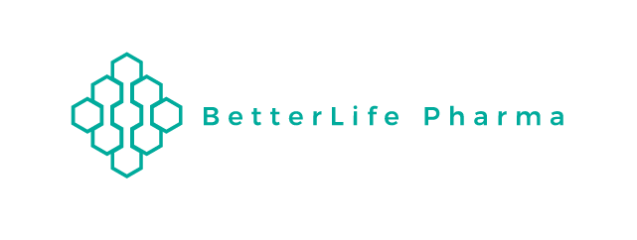
Press:
BetterLife Resumes Trading Following CSE Merger Ratification with Altum Pharmaceuticals
BetterLife Pharma Inc. (“BetterLife” or the “Company”) (CSE: BETR / OTCQB: BETRF / FRA: NPAT) is pleased to announce that it has received confirmation from the Canadian Stock Exchange (the "Exchange") that its common shares will resume trading on Tuesday, September 1, 2020. Trading on the OTC is expected to resume shortly thereafter. The Exchange’s Listing Committee has approved Betterlife’s new Listing Statement after having received satisfactory documentation with respect to the merger, announced July 30, 2020, with Altum Pharmaceuticals Inc. Completion of the merger had been subject to final Exchange acceptance.
Dr. Ahmad Doroudian, CEO of the newly merged entity, stated: “I am pleased that the merger process we started in late June is finally complete. We can now earnestly begin to advance our therapeutic pipeline consisting of 3 products with enormous potential.”
“I would also like to thank our shareholders for their patience during the trading halt. The merger transaction was subject to requisite regulatory approval, including the completion of due diligence to the satisfaction and approval of the Canadian Stock Exchange.
“Finally, we have been working diligently during the halt on advancing our clinical trials involving AP-003, our interferon a2b (IFNa2b) inhalation formulation, which we believe (from recent studies in China and the UK) could be an effective therapeutic against COVID-19. We are looking forward to sharing additional updates over the coming weeks.’’
Cautionary Note
The Company is not making any express or implied claims that Altum's AP-003 or any other product has the ability to eliminate, cure or contain the COVID-19 (or SARS-2 Coronavirus) at this time.
About BetterLife Pharma Inc.

BetterLife Pharma Inc. is an emerging biotechnology company engaged in the development and commercialization of therapeutic pharmaceuticals as well as drug delivery platform technologies. BetterLife is refining and developing drug candidates from a broad set of complementary interferon-based technologies which have the potential to engage the immune system to fight virus infections, such as the coronavirus disease (COVID-19) and human papillomavirus (HPV), and/or to directly inhibit tumours to treat specific types of cancer.

For further information please visit www.blifetherapeutics.com.

Contact
Ahmad Doroudian, Chief Executive Officer
Email: Ahmad.Doroudian@blifepharma.com
Phone: 604-221-0595

Dost Mustaq, BDA International Investor Relations Contact
Email: ir@blifepharma.com
Phone: 646-679-4321

Cautionary Note Regarding Forward-Looking Statements

Except for historical information, the matters set forth above may be forward-looking statements that involve risks and uncertainties that could cause actual results to differ from those in the forward-looking statements. Such forward-looking statements are based on the current beliefs of management, as well as assumptions made by and information currently available to management. Actual results could differ materially from those contemplated by the forward-looking statements as a result of certain factors. Reliance should not be placed on forward-looking statements, as they involve known and unknown risks, uncertainties and other factors that may cause the actual results to differ materially from the anticipated future results expressed or implied by such forward-looking statements. Factors that could cause actual results to differ materially from those set forward in the forward-looking statements include, but are not limited to: our ability to obtain, on satisfactory terms or at all, the capital required for research, product development, operations and marketing; general economic, business and market conditions; our ability to successfully and timely complete clinical studies; product development delays and other uncertainties related to new product development; our ability to attract and retain business partners and key personnel; the risk of our inability to profitably commercialize our proposed products; the risk that our proposed clinical trials will not be launched in a timely manner (or at all) or if launched yield positive results or that we will not obtain regulatory market approvals for our products; the extent of any future losses; the risk of our inability to establish or manage manufacturing, development or marketing collaborations; the risk of delay of, or failure to obtain, necessary regulatory approvals and, ultimately, product launches; dependence on third parties for successful commercialization of our products; inability to obtain product and raw materials in sufficient quantity or at standards acceptable to health regulatory authorities to commence and complete clinical trials or to meet commercial demand; our ability to obtain patent protection and protect our intellectual property rights; commercialization limitations imposed by intellectual property rights owned or controlled by third parties; uncertainty related to intellectual property liability rights and liability claims asserted against us; the impact of competitive products and pricing; and future levels of government funding; additional risks and uncertainties, many of which are beyond our control.

Except as required by law, we undertake no obligation to publicly update any forward-looking statements, whether as a result of new information, future events or otherwise.

