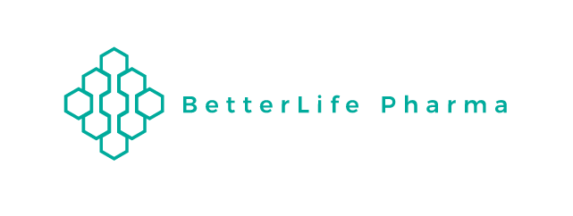

BetterLife Pharma issues update on its promotional activity

VANCOUVER, July 24, 2020 - BetterLife Pharma Inc. (“BetterLife” or the “Company”) (CSE: BETR / OTCQB: BETRF / FRA: NPAT) provides the following information about certain promotional activities at the request of OTC Markets.

Recently, BetterLife has proactively engaged a number of entities to help raise its profile as an emerging biotechnology company and to raise awareness of its potential Interferon based Coivid-19 treatment. Towards this end, Betterlife entered into a consulting agreement with GRA Enterprises LLC (dba ‘National Inflation Association’) to provide media and communication services. Under the six month agreement, the Company will compensate National Inflation Association $50,000. Furthermore, over the course of the previous 12 months, BetterLife has also retained investor relations and media services of Grit Capital Advisory Inc. and Equity Guru Media Inc. to support its efforts to raise expansion capital.

On July 22, 2020, BetterLife was notified by OTC Markets that on July 20 and 21, 2020, certain materials promoting the Company’s common shares were circulated via email by a third party. Copies of the promotional emails were forwarded to BetterLife by OTC Markets.

Upon immediate inquiry BetterLife determined that the aforementioned promotional emails were sent by National Inflation Association. The consulting agreement that the Company has with GRA Enterprises LLC requires that National Inflation Association submit, before publication and distribution, any content for approval. While the content of the promotional pieces was factually correct, BetterLife on this occasion was not provided an opportunity to review and approve the content distributed on July 20th and 21st, 2020.

Specifically, the Company notes that with exception of content pertaining to Dr. E. Fish who having accepted a government position (and to avoid any potential conflicts of interest) is no longer part of the Company’s advisory board, the statements made in the promotional materials were not materially false or misleading and were based on previously released Company news or other previously disclosed public information.

The Company believes the promotional activity may have been a factor with respect to an increased price and trading volume concerning the Company’s common shares that occurred on July 22, 2020 following the promotional activity.

However, the increase in share price and volume during this period also corresponds with the CEO of the Company, Dr. Doroudian conducting various public interviews (on July 22, July 16, July 15 ) discussing the Company’s Interferon based Covid-19 treatment. More significantly, media coverage of a recent successful Interferon based Covid-19 trial in the UK published July 20th, may also have been a major factor with respect to such increased price and trading volume on that particular day.

BetterLife, can confirm that upon inquiry with its officers, directors, employees and controlling shareholders (defined as shareholders owning 10% or more of BetterLife’s securities) that, though payment for the promotional materials are included in the compensation for services to National Inflation Association, they were in no way directly or indirectly involved in the creation or distribution for the promotional materials.

BetterLife can also confirm, after inquiry, that no controlling shareholders, directors, officers or third-party service providers purchased or sold Company stock at any time within the past 90 days except as follows: a director of the Company purchased 19,000 shares at an average price of CDN$2.44 in May 2020 and an officer purchased 1,000 shares (average price CDN$1.30) and sold 8,000 shares (average prices between $1.50 and $1.82) within the past 90 days.

BetterLife has not, over the past 12 months, issued any common shares or convertible instruments allowing conversion to equity securities at prices constituting a discount to current market price

At the current time, Betterlife has also retained the services of BDA International Inc. to provide strategic public/investor relations services.

About BetterLife Pharma Inc.

BetterLife Pharma Inc. is a science-based innovative medical wellness company aspiring to offer high-quality preventive and self-care products to its customers. For further information please visit abetterlifepharma.com.

Contact:
Ahmad Doroudian, Chief Executive Officer
Email: Ahmad.Doroudian@blifepharma.com
Phone: 604-221-0595

Dost Mustaq, BDA International Investor Relations Contact
Email: ir@blifepharma.com
Phone: 646-679-4321

Cautionary Note Regarding Forward-Looking Statements

All statements, other than statements of historical fact, included herein are forward-looking statements that involve various risks and uncertainties. There can be no assurance that such statements will prove to be accurate and actual results and future events could differ materially from those anticipated in such statements. The forward-looking statements contained in this news release are made as at the date of this news release and BetterLife does not undertake any obligations to publicly update and/or revise any of the included forward-looking statements, whether as a result of additional information, future events and/or otherwise, except as may be required by applicable securities laws.

