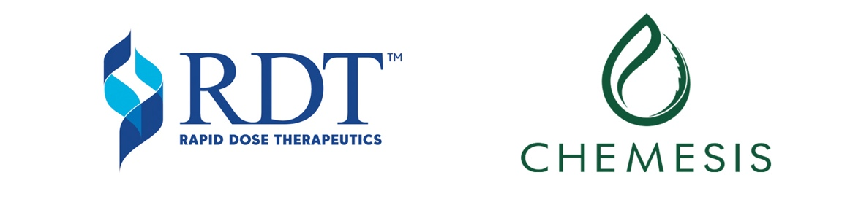

RAPID DOSE THERAPEUTICS COMPLETES QUICKSTRIP™
EQUIPMENT INSTALLATION IN PUERTO RICO
AND GRANTS STOCK OPTIONS

Burlington, Ontario – September 4, 2019 – Rapid Dose Therapeutics Corp. (“RDT”) (CSE: DOSE) announced today that the installation of its QuickStrip™production equipment at Chemesis International Inc. (“Chemesis”) (CSE: CSI) (OTC: CADMF) (FRA: CWAA) is now complete, enabling the immediate recognition of revenue to RDT under the Managed Strip Services Agreement signed in October 2018 (the “Agreement”).

Under the Agreement, Chemesis has been granted the right to manufacture, distribute and sell RDT’s QuickStrip™ innovative, proprietary delivery technology products to the cannabis market in the US Territory of Puerto Rico.

RDT’s proprietary QuickStrip™ technology is a Quick, Convenient, Precise, Discreet™ oral fast-dissolving drug delivery system providing cannabis consumers a smoke-free alternative, while simultaneously offering health benefits and improving patient outcomes.

“RDT remains committed to providing global consumers in the cannabis markets a Smoke-Free Choice™ that they can consume Anytime, Anywhere™. As these markets evolve and expand, RDT will be at the forefront of innovative cannabis delivery,” said Mark Upsdell, CEO of RDT. “We are pleased to have Chemesis as our partner in Puerto Rico, which further strengthens and positions QuickStrip™ as a growing international brand and delivery device,” added Upsdell.

RDT also announced the grant of options to an officer and employees to purchase 1,100,000 common shares of the Corporation, exercisable at $0.82 per share at any time on or before July 29, 2024. The grants are subject to the terms of RDT’s stock option plan. In accordance with securities regulatory requirements, any shares issued pursuant to the exercise of such options will be subject to a resale restriction for a period of four months from the date of the grant.

About Rapid Dose Therapeutics Corp.
Rapid Dose Therapeutics Corp. is a publicly-traded Canadian life sciences company that provides innovative, proprietary drug delivery technologies designed to improve outcomes and quality of lives. RDT offers Quick, Convenient, Precise and Discreet™ choices to consumers. RDT is focused and committed to clinical research and product development for the healthcare manufacturing industry, including nutraceutical, pharmaceutical and cannabis industries. Within the cannabis sector, RDT provides a turn-key Managed Strip Service Program which enables RDT’s QuickStrip™ proprietary drug delivery technology to be licensed by select partners. RDT’s service-based annuity contracts drive recurring revenue which enables rapid expansion into emerging markets — generating value for consumers and shareholders. Rapid Dose Therapeutics is committed to continually create innovative solutions aimed at multiple consumer segments and future market needs — including humans, animals and plants.
For more information, visit: www.rapid-dose.com

For inquiries please contact:
Ian Fodie, CFO Ali Mahdavi, Managing Director
Rapid Dose Therapeutics Corp. Spinnaker Capital Markets Inc.
ifodie@rapid-dose.com am@spinnakercmi.com
Office (416) 477-1052 Office (416) 962-3300

Social Media
RapidDoseTherapeutics.linkedin
RapidDoseTherapeutics.twitter
RapidDoseTherapeutics.facebook
QuickStrip.instagram

CAUTIONARY NOTE REGARDING FORWARD-LOOKING STATEMENTS: Certain information in this news release may contain forward-looking information within the meaning of applicable securities laws. Any statements that are contained in this news release that are not statements of historical fact may be deemed to be forward- looking statements. Forward looking statements are often identified by terms such as “may”, “should”, “anticipate”, “expect”, “potential”, “believe”, “intend” or the negative of these terms and similar expressions. Statements containing forward-looking information, including, without limitation, in respect of the delivery of products using the QuickStrip™ product delivery method, express, as at the date of this news release, the plans, estimates, forecasts, projections, expectations or beliefs of RDT as to future events or results and are believed to be reasonable based on information currently available to them. Forward-looking statements necessarily involve known and unknown risks, including, without limitation, risks associated with general economic conditions; adverse industry events; marketing costs; loss of markets; future legislative and regulatory developments involving cannabis; inability to access sufficient capital from internal and external sources, and/or inability to access sufficient capital on favourable terms; the cannabis industry in Canada generally, income tax and regulatory matters; the ability to implement its business strategies; competition; currency and interest rate fluctuations and other risks. Readers are cautioned that the foregoing list is not exhaustive. There can be no assurance that statements of forward-looking information, although considered reasonable by management at the time of preparation, will prove to be accurate as there can be no assurance that the plans, intentions or expectations upon which they are based will occur. Actual results and future events could differ materially from those anticipated in such statements. Readers should not place undue reliance on forward-looking information. Forward-looking statements contained in this news release are expressly qualified by this cautionary statement.

