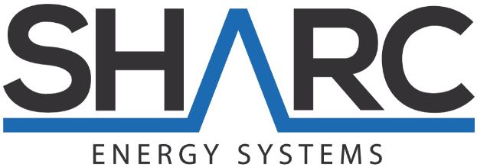
1443 Spitfire plaCE | Port Coquitlam, BC | V3c 6L4 | CANADA

PRESS RELEASE July 17, 2018
SHARC CEO Lynn Mueller Nominated for 2018 E.C. Manning Innovation Awards
VANCOUVER, Canada -- Sharc International Systems Inc. (CSE: SHRC) (FSE: IWIA) (OTCQB: INTWD) ("SHARC" or "the Company") is pleased to announce that the Company’s CEO, Lynn Mueller and the revolutionary SHARC™ wastewater heat exchange system has been nominated for the 2018 Ernest C. Manning Innovation Awards for the British Columbia and Yukon region.
The 2018 Manning Innovation Awards encourage imaginative innovators to take a chance and create something that will positively impact Canada and the world for many years to come. Awards are given to the most ground-breaking and modern nominees across Canada.
Every year since 1982, the Ernest C. Manning Awards Foundation has been creating a culture of innovation in Canada by discovering, celebrating and rewarding Canadian innovators of all ages. They tell the stories of Canadian innovators who are improving the lives of Canadians and others around the world through their commercialized innovations. Nominees may be eligible for one of four Awards, from the $100,000 Principal Award to the $10,000 Innovation Award.
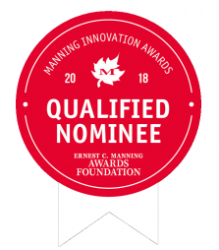
Lynn Mueller, Chief Executive Officer of SHARC stated, “We are humbled to have been nominated for an E.C. Manning Award as one of the best and brightest innovators Canada has to offer, and shows the dedication of the SHARC stakeholders and its employees who work so hard to provide the right outcomes for the environment.”

About SHARC International Systems
SHARC International Systems Inc. is a world leader in thermal heat recovery. SHARC™ technology systems recycle thermal energy from wastewater, generating one of the most energy efficient and economical systems for heating, cooling & hot water preheating for commercial, residential and industrial buildings. SHARC is publicly traded in Canada (CSE: SHRC), the United States (OTCQB: INTWF) and Germany (Frankfurt: IWIA).
Further information about the Company is available on our website at www.sharcenergy.com or under our profile on SEDAR at www.sedar.com.
ON BEHALF OF THE BOARD
“Lynn Mueller”
Chairman and Chief Executive Officer

For further information, please contact:
Ray Crowley
Telephone: 604 788 1091
Email: ray.crowley@sharcenergy.com

Neither the Canadian Securities Exchange nor its Regulation Services Provider (as that term is defined in policies of the Canadian Securities Exchange) accepts responsibility for the adequacy or accuracy of this release.
Forward-Looking Statements
Certain statements contained in this news release may constitute forward-looking information. Forward-looking information is often, but not always, identified by the use of words such as "anticipate", "plan", "estimate", "expect", "may", "will", "intend", "should", and similar expressions. Forward-looking information involves known and unknown risks, uncertainties and other factors that may cause actual results or events to differ materially from those anticipated in such forward-looking information. SHARC's actual results could differ materially from those anticipated in this forward-looking information as a result of regulatory decisions, competitive factors in the industries in which the Company operates, prevailing economic conditions, and other factors, many of which are beyond the control of the Company. SHARC believes that the expectations reflected in the forward-looking information are reasonable, but no assurance can be given that these expectations will prove to be correct and such forward-looking information should not be unduly relied upon. Any forward-looking information contained in this news release represents the Company's expectations as of the date hereof, and is subject to change after such date. The Company disclaims any intention or obligation to update or revise any forward-looking information whether as a result of new information, future events or otherwise, except as required by applicable securities legislation.
###

