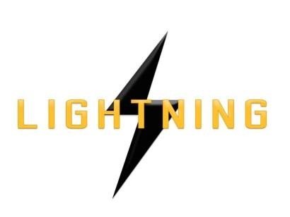

Lightning Ventures Inc.
Suite700-838 W Hastings Street, Vancouver, BC, V6C 0A6

Lightning Industries Partners with Oilengy for Commercialization and Product Promotion in Multiple Geographical Regions

VANCOUVER, CANADA, December 12, 2017 – Lightning Ventures Inc. (CSE: LVI) (Frankfurt: 1HM) (the “Company”) is pleased to announce that its wholly-owned subsidiary, Lightning Industries, has contracted with Oilengy Mexico S.A. de C.V. (“Oilengy”) to install, operate, and maintain the Pemex pilot project on behalf of Lightning Industries. The pilot will commence during the week of January 11th through the 15th on a well in the Tamaulipas field. Oilengy will be responsible for preparing the reports presented to Pemex at the conclusion of the pilot.

In addition, Lightning Industries entered into a Strategic and Commercial Alliance Agreement with Oilengy to promote Lightning’s product lines in Mexico, Brazil, Venezuela, Colombia, Ecuador, and Argentina.

Don Rainwater, President and CEO, commented: “Oilengy México is based in Monterrey, N.L., México and has extensive experience in the oil and gas sectors in Latin America. Latin American oil production is dominated by Brazil, Mexico, and Venezuela. These countries rank as the world's ninth, tenth and twelfth largest oil producers, respectively. Our alliance will expedite market penetration and accelerate revenue opportunities in these key petrochemical geographical segments.”

About Lightning Ventures

Lightning Ventures Inc. (CSE: LVI) (Frankfurt: 1HM) is an oil and gas industrial services company. It operates a specialty manufacturing business based in Hobbs, New Mexico through its subsidiary Lightning Industries, Inc., which provides products to enhance efficiency and increase the production of oil and gas wells.
Further information about Lightning Ventures is available under its profile on the SEDAR website www.sedar.com and at www.lightningind.com.
For further information on the Company, please contact:
Donald Rainwater
Chief Executive Officer
Lightning Ventures Inc.
Telephone: 210-535-5700
Email: don@rainwater-investments.com
Neither the Canadian Securities Exchange nor its Market Regulator (as that term is defined in the policies of the Canadian Securities Exchange) accepts responsibility for the adequacy or accuracy of this release.

This news release may contain forward-looking statements based on assumptions and judgments of management regarding future events or results. Such statements are subject to a variety of risks and uncertainties which could cause actual events or results to differ materially from those reflected in the forward-looking statements. The company disclaims any intention or obligation to revise or update such statements.

