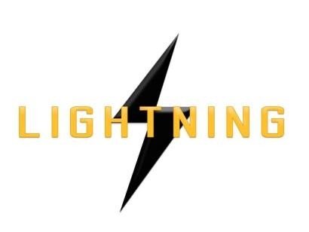

Lightning Ventures Inc.
Suite700-838 W Hastings Street, Vancouver, BC, V6C 0A6

Lightning Industries Engaged by Blue Marble Resources for 60 Oil Storage Tanks

VANCOUVER, CANADA, November 1, 2017 – Lightning Ventures Inc. (CSE: LVI) (Frankfurt: 1HM) (the “Company”) is pleased to announce that its wholly-owned subsidiary, Lightning Industries (“Lightning”), has been engaged by Blue Marble Resources to provide tank-cleaning services for 60 oil storage tanks. Final contract amounts will be established once tank inspections and analysis have been completed by Lightning.

Lightning will commence field operations November 7, 2017.

Blue Marble Resources is headquartered in Houston, Texas and operates 80 leases in the South Texas region.

Don Rainwater, CEO of Lightning, comments: "Blue Marble is a large and recognized operator in Texas and they have numerous oil wells and leases. This is a substantial initiative for the company and this contract could serve as a door opener to other large operators."

About Lightning Ventures

Lightning Ventures Inc. (CSE: LVI) (Frankfurt: 1HM) is an oil and gas industrial services company. It operates a specialty manufacturing business based in Hobbs, New Mexico through its subsidiary Lightning Industries, Inc., which provides products to enhance efficiency and increase the production of oil and gas wells.
Further information about Lightning Ventures is available under its profile on the SEDAR website www.sedar.com and at www.lightningind.com.
For further information on the Company, please contact:
Donald Rainwater
Chief Executive Officer
Lightning Ventures Inc.
Telephone: 210-535-5700
Email: don@rainwater-investments.com
Neither the Canadian Securities Exchange nor its Market Regulator (as that term is defined in the policies of the Canadian Securities Exchange) accepts responsibility for the adequacy or accuracy of this release.

This news release may contain forward-looking statements based on assumptions and judgments of management regarding future events or results. Such statements are subject to a variety of risks and uncertainties which could cause actual events or results to differ materially from those reflected in the forward-looking statements. The company disclaims any intention or obligation to revise or update such statements.

