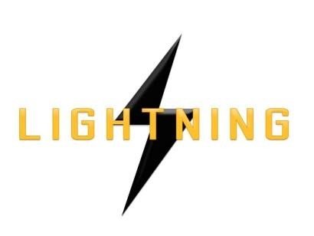

Lightning Ventures Inc.
Suite700-838 W Hastings Street, Vancouver, BC, V6C 0A6

LIGHTNING VENTURES PROVIDES UPDATE ON MANAGEMENT CEASE TRADE ORDER

VANCOUVER, CANADA, August 15th, 2017 – Lightning Ventures Inc. (CSE: LVI) (Frankfurt: 1HM) provides this update on its continuing efforts to seek revocation of the management cease trade order entered against the Company and its executives by the British Columbia Securities Commission on August 1, 2017 for the Company’s failure to file its annual financial statements and management’s discussion and analysis for the year ended March 31, 2017, together with the related certifications (collectively, the “Disclosure Documents”) on or before the prescribed filing deadline of July 31, 2017 as required by National Instrument 51-102, Continuous Disclosure Obligations, and NI 52-109, Certification of Disclosure in Issuers’ Annual and Interim Filings, respectively. Pursuant to the requirements of National Policy 12-203, Management Cease Trade Orders, the Company is required to issue bi-weekly default status reports, in the form of news releases, with respect to its efforts to achieve compliance. The Company announces that it continues to work with its auditors on the completion of the Disclosure Documents. The Company continues to anticipate that it will be in a position to file the Disclosure Documents before August 30, 2017. The Company confirms that it will comply with the alternative information guidelines included in National Policy 12-203, Management Cease Trade Orders, for so long as it remains in default of a specified requirement.

About Lightning Ventures

Lightning Ventures Inc. (CSE: LVI) (Frankfurt: 1HM) is an oil and gas industrial services company. It operates a specialty manufacturing business based in Hobbs, New Mexico through its subsidiary Lightning Industries, Inc., which provides products to enhance efficiency and increase the production of oil and gas wells.
Further information about Lightning Ventures is available under its profile on the SEDAR website www.sedar.com and at www.lightningind.com.
For further information on the Company, please contact:
Donald Rainwater
Chief Executive Officer
Lightning Ventures Inc.
Telephone: 210-535-5700
Email: don@rainwater-investments.com
Neither the Canadian Securities Exchange nor its Market Regulator (as that term is defined in the policies of the
Canadian Securities Exchange) accepts responsibility for the adequacy or accuracy of this release.

