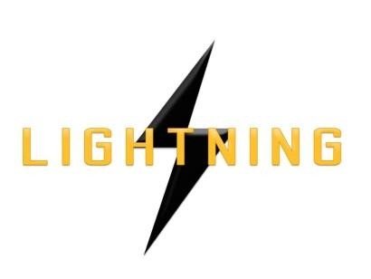

Lightning Ventures Inc.
Suite700-838 W Hastings Street, Vancouver, BC, V6C 0A6

LIGHTNING VENTURES PROVIDES CORPORATE UPDATE

VANCOUVER, CANADA, June 29, 2017 – Lightning Ventures Inc. (CSE: LVI) (OTCBB: HMKTF) (Frankfurt: 1HM) (the “Company”) is pleased to provide the following corporate update on the Company's activities and future plans.
The Company recently closed an over-subscribed financing for $579,500 involving a number of selective, strategic investors. Proceeds will be used to recruit an experienced, global sales and marketing team to exploit the Company’s existing production-enhancing product line consisting of the following: Lightning Scrubber Pot, Solar Compressor, Soap Sticks, Lightning Auto Loader, 50k Load Cell, Lightning Flare Ignitor, LT 250 Sand Separator and Hot Oil Trailer. The Company will also use proceeds to solidify and expand the Intellectual Property around its high-tech products, including its approved United States Patent for the Automatic Soap Stick Launcher and its pending United States Patent for the Automatic Chemical Injection System.
New Board members have been recently appointed, namely, Kelly Pladson and Keith Anderson. The Company will be looking to establish an Advisory Board consisting of oil and gas specialists to give the Company greater global corporate profile in the sector as it relates to the technology segment.
Don Rainwater, President and CEO, commented: "The time has come for us to cut a large marketing swath in the oil and gas space. Our industry-leading technology product line enables oil and gas companies to improve their production metrics and to reduce overall expenses. We are building a pipeline of deal-flow and are ramping up our efforts to achieve greater near-term revenue production."
About the Company

The Company is an oil and gas industrial services company. It operates a specialty manufacturing business based in Hobbs, New Mexico through its subsidiary Lightning Industries, Inc., which provides products to enhance efficiency and increase the production of oil and gas wells.

Further information about Lightning is available under its profile on the SEDAR website www.sedar.com and at www.lightningind.com.

For further information on the Company, please contact:

Donald Rainwater Chief Executive Officer Lightning Ventures Inc.
Telephone: 210-535-5700
Email: don@rainwater-investments.com

Neither the Canadian Securities Exchange nor its Market Regulator (as that term is defined in the policies of the Canadian Securities Exchange) accepts responsibility for the adequacy or accuracy of this release.

This news release may contain forward-looking statements based on assumptions and judgments of management regarding future events or results. Such statements are subject to a variety of risks and uncertainties which could cause actual events or results to differ materially from those reflected in the forward looking statements. The company disclaims any intention or obligation to revise or update such statements.

