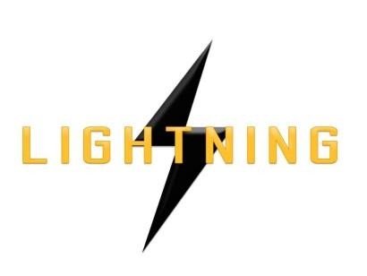

Lightning Ventures Inc.
Suite700-838 W Hastings Street, Vancouver, BC, V6C 0A6

LIGHTNING ANNOUNCES CHANGE OF DIRECTOR & OFFICER

VANCOUVER, CANADA, June 12, 2017 – Lightning Ventures Inc. (CSE: LVI) (OTCBB: HMKTF) (Frankfurt: 1HM) is pleased to announce the appointment of Kelly Pladson as Corporate Secretary and a Director of the Company, effective immediately.
Kelly Pladson has acted as Corporate Secretary and provided corporate governance and regulatory compliance services to many TSX Venture and CSE listed companies since 2009. She works closely with the company’s CEO and legal counsel in maintaining corporate records, managing the day-to-day operations of the company and ensuring the company’s filings with the securities commissions and exchanges are accurately filed and in accordance with their deadlines. Prior to 2009, Ms. Pladson was an investment advisor’s assistant for two years.
The Company has accepted the resignation of Marc Branson as a Director of the Company. The Company wishes to thank Mr. Branson for his contributions to the Company and wishes him the best in his future endeavours.

About the Company

The Company is an oil and gas industrial services company. It operates a specialty manufacturing business based in Hobbs, New Mexico through its subsidiary Lightning Industries, Inc., which provides products to enhance efficiency and increase the production of oil and gas wells.

Further information about Lightning is available under its profile on the SEDAR website www.sedar.com and at www.lightningind.com.

For further information on the Company, please contact:

Donald Rainwater Chief Executive Officer Lightning Ventures Inc.
Telephone: 210-535-5700
Email: don@rainwater-investments.com

