Imagination Park Film “Spoken Word” Chosen as an Official Selection at the 15th Annual Garden State Film Festival in New Jersey and the Newport Beach Film Festival
Vancouver, BC – March 27, 2017 – Imagination Park Entertainment Inc. (CSE: IP) (OTC: IPNFF) (FRA: GMS1) (“Imagination Park” or the “Company”) is pleased to announce that it’s short film “Spoken Word” has been chosen to be screened at the 15th Annual Garden State Film Festival in New Jersey March 30 - April 2, 2017 as well as the Newport Beach Film Festival which takes place April 20-27, 2017.

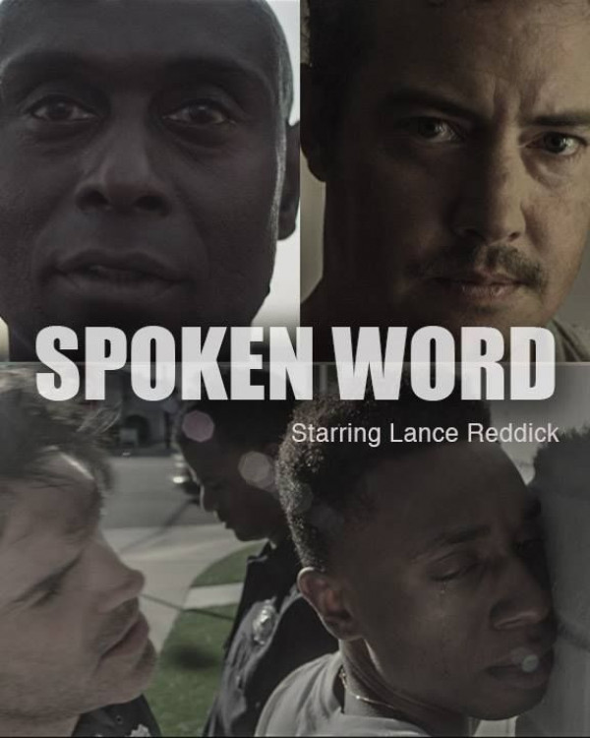
“Spoken Word” was produced by Gabriel Napora and Tim Marlowe of Imagination Park, directed by Ilan Srulovicz, acclaimed actor, and stars Lance Reddick as an African-American judge in a moral conflict. Race, perception and consequence become the center point of three lives, as Judge Matthews realizes that he can no longer overlook his actions from the bench.
Imagination Park plans to develop “Spoken Word” into a full-length feature film.

“Spoken Word” has already been awarded BEST FEATURE FILM from the Independent Cinema Foundation and Festival Academy and Spoken Word star, actor Lance Reddick, won the ICFFA award for BEST ACTOR.
Gabriel Napora, CEO of Imagination Park, states: “We’re very happy with how well this film has performed and being featured at great festivals such as these reflects our quality of work. Everyone in the Company started in the entertainment industry so they could tell meaningful, entertaining stories and there’s nothing that is going to stop us from doing that. We are more committed now than ever before to delivering world class content in both the virtual reality / augmented reality and film areas."
The official trailer for the film is available for viewing here: https://vimeo.com/198632658
About Imagination Park
Imagination Park is an emerging digital content production company, working with talented filmmakers around the world to bring conventional as well as virtual reality content to life.

For more information or to explore working with Imagination Park, please call 604.446.7325, email info@imaginationpark.com, or visit www.imaginationpark.com.

ON BEHALF OF THE BOARD,

Gabriel Napora
CEO & Director

The Canadian Securities Exchange has neither approved nor disapproved the contents of this press release.
This press release may include ‘forward-looking information’ within the meaning of Canadian securities legislation, concerning the business of the Company. The forward looking information is based on certain key expectations and assumptions made by Imagination Park’s management. Although Imagination Park believes that the expectations and assumptions on which such forward- looking information is based are reasonable, undue reliance should not be placed on the forward-looking information because Imagination Park can give no assurance that it will prove to be correct. These forward-looking statements are made as of the date of this press release, and Imagination Park disclaims any intent or obligation to update publicly any forward-looking information, whether as a result of new information, future events or results or otherwise, other than as required by applicable securities laws.

