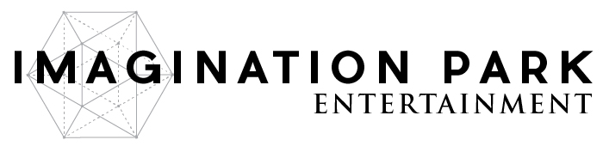
Imagination Park Signs Multi-Year Content Licensing Agreement With China’s Largest Media Platform For Virtual Reality & Short Films.
Vancouver, BC – March 6, 2017 – Imagination Park Entertainment Inc. (CSE: IP) (OTC: IPNFF) (“Imagination Park” or the “Company”) is proud to announce a multi-year content license agreement with Ohmore Media Inc. Ohmore Media is a partner of the Ergeng Network, the largest new media platform in China. With over 50 billion page views per month, and more than 200 distribution channels, it is one of the largest content sites globally.
Imagination Park will provide Virtual Reality content and short films to Ohmore Media, a company that plays a leading role in producing online videos; attracting online traffic and building brand awareness in China. Imagination Park grants Ohmore Media Inc. a non-exclusive, China-wide license to broadcast the original financed content on any of Ohmore Media’s 227 channels. Under the executed agreement, Ohmore Media will share advertising revenue 50/50 with Imagination Park. According to China Internet Watch, China’s online advertising market reached 73.87 billion yuan (US$10.76 billion), in 2016.
Ohmore Media and the Ergeng Network have attracted over 50 billion page views by working with 140 major video websites, social media platforms, and engaging offline advertising properties. Ohmore Media has established partnerships globally including in London and Los Angeles.
CEO and Director Gabriel Napora stated: “The Chinese market is massive and the desire for content is growing exponentially. To have a partner like Ohmore Media licensing our content could be very lucrative for the company and advances Imagination Park into the Chinese market in a way few North American companies have been able to achieve to date. This agreement puts Imagination Park on the map in China and provides a foundation to build a profitable long-term relationship with one of the world’s top content aggregators.”

The licensing agreement was executed by Gabriel Napora for Imagination Park Entertainment. Imagination Park’s original content is expected to be broadcast on the Ohmore Media network within 60 days.

About Imagination Park
Imagination Park is an emerging digital content production company, working with talented filmmakers around the world to bring conventional as well as virtual reality content to life.

For more information or to explore working with Imagination Park, please call 604.446.7325, email info@imaginationpark.com, or visit www.imaginationpark.com.

ON BEHALF OF THE BOARD,

Gabriel Napora
CEO & Director

The Canadian Securities Exchange has neither approved nor disapproved the contents of this press release. This press release may include ‘forward-looking information’ within the meaning of Canadian securities legislation, concerning the business of the Company. The forward looking information is based on certain key expectations and assumptions made by Imagination Park’s management. Although Imagination Park believes that the expectations and assumptions on which such forward- looking information is based are reasonable, undue reliance should not be placed on the forward-looking information because Imagination Park can give no assurance that it will prove to be correct. These forward-looking statements are made as of the date of this press release, and Imagination Park disclaims any intent or obligation to update publicly any forward-looking information, whether as a result of new information, future events or results or otherwise, other than as required by applicable securities laws.

