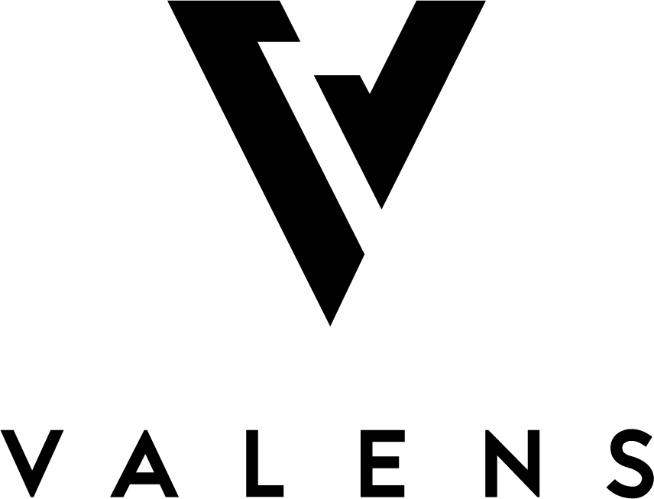
For Immediate Release February 13, 2019

VALENS INCREASES EXTRACTION CAPACITY SIGNIFICANTLY TO 240,000KG
New Capacity Makes Valens the Largest Third-Party Extraction Company in Canada

Kelowna, B.C., February 13, 2019 – Valens GroWorks Corp. (CSE: VGW, OTC: VGWCF) (the “Company” or “Valens”), a multi-licensed, vertically integrated provider of cannabis products and services focused on various proprietary extraction methodologies, distillation, cannabinoid isolation and purification, as well as associated quality testing, is pleased to announce that it has expanded its annual extraction capacity significantly to 240,000KG of dried cannabis input in order to prepare for customer demand for extraction services.
With this expansion, Valens secures the spot as the largest third-party extraction company in Canada. “We are building a footprint to not only meet the needs of our Canadian customers but meet the needs of the global cannabis marketplace,” said Tyler Robson, CEO of Valens GroWorks. “With edibles and concentrates becoming available later this year in Canada, we must be ready for a shift in consumer demand and in turn be flexible and scalable in our offerings for our clients to meet that demand.”
Valens is able to offer its customers a range of extraction services including crude oil, winterized oil, distillate, and isolate to meet their end product needs. “We have also expanded our product offerings to formulate and customize our clients’ products with regards to vape pens, edibles and concentrates, cannabis infused beverages, tinctures, and capsules as they become available,” Mr. Robson continued. “The future of cannabis in Canada is coming and we are going to be at the forefront.”
About Valens GroWorks
Valens GroWorks Corp. is a research-driven, vertically integrated Canadian cannabis company focused on downstream secondary extraction methodology, distillation and cannabinoid isolation and purification, as well as associated quality testing with three wholly-owned subsidiaries located in and around Kelowna, BC. Subsidiary Valens Agritech (“VAL”) holds a license to cultivate cannabis and produce cannabis oil under the Cannabis Act, as well as a license to conduct analytical testing for the cannabis industry. VAL currently has extraction processing and supply agreements with various leading producers across Canada. Subsidiary Valens Labs is a Health Canada licensed ISO 17025 accredited cannabis testing lab providing sector-leading analytical services and has partnered with Thermo Fisher Scientific to develop a Centre of Excellence in Plant-Based Science. Subsidiary Valens Farms is in the process of becoming a purpose-built facility in compliance with European Union (EU) Good Manufacturing Practices (GMP) standards, ensuring the product from this facility can be exported anywhere in the world where cannabis is nationally legal for medical or adult usage purposes. For more information, please visit http://valensgroworks.com. The Company’s investor deck can be found specifically at http://valensgroworks.com/investors/
For further information, please contact:
Scott Young
Telephone: +1.705.888.2756
Notice regarding Forward Looking Statements
This news release contains certain "forward-looking statements" within the meaning of such statements under applicable securities law. Forward-looking statements are frequently characterized by words such as “anticipates”, "plan", "continue", "expect", "project", "intend", "believe", "anticipate", "estimate", "may", "will", "potential", "proposed", “positioned” and other similar words, or statements that certain events or conditions "may" or "will" occur. These statements are only predictions. Various assumptions were used in drawing the conclusions or making the projections contained in the forward-looking statements throughout this news release. Forward-looking statements are based on the opinions and estimates of management at the date the statements are made and are subject to a variety of risks and uncertainties and other factors that could cause actual events or results to differ materially from those projected in the forward-looking statements. The Corporation is under no obligation, and expressly disclaims any intention or obligation, to update or revise any forward-looking statements, whether as a result of new information, future events or otherwise, except as expressly required by applicable law.
The CSE or other regulatory authority has not reviewed, approved or disapproved the contents of this press release. We seek Safe Harbour.

