ORCHID VENTURES ANNOUNCES LAUNCH OF
THREE NEW PRODUCT LINES AND EXPANDED INVENTORY PRODUCTION
VANCOUVER, WA - September 23, 2020 - ORCHID VENTURES, INC. (CSE: ORCD OTC: ORVRF) (the “Company” or “Orchid”), a multi-state cannabis innovation company, is pleased to announce that it is launching three new product lines in California and Oregon.

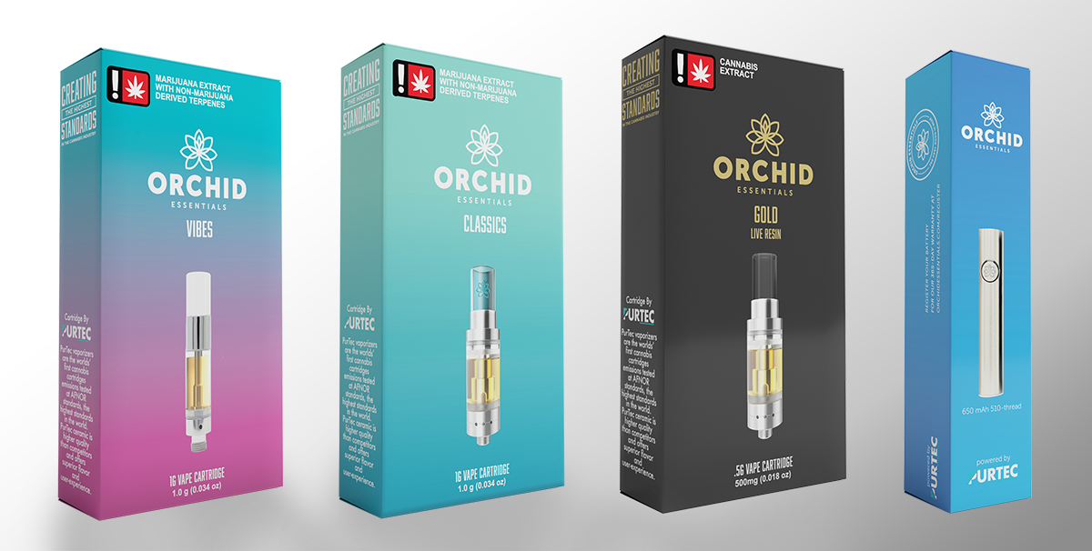
Pictured from left to right: Orchid Vibes, Orchid Classics, Orchid Gold, Orchid Battery

The Orchid Brands team has been hard at work developing three news lines of vape products as the company has seen a complete rebound in vape sales since the vape scare of 2019. These products have been developed and will be positioned to appeal to different consumer segments. Firstly, there is Orchid Vibes, a value-priced product featuring a newly developed PurTec Summit cartridge and introducing more contemporary terpene profiles like Mimosa and Purple Punch. The company has also improved the Orchid Classic line up, which are mid-tier products featuring their classic Orchid Essential formulations like Jack Herer and Dutch Treat among many other terpene profiles, all available in their best-in-class Orchid hardware. Lastly, the company is introducing Orchid Gold, live resin seasonal craft strains and flavors that rotate throughout the year and are also available in their top-tier Orchid hardware. The new product lines are currently being launched into the Oregon market through an Orchid Licensee, Tine Trading Company, and in California through partnerships with contract manufacturers and the company’s evolving distribution network. Orchid California and Orchid Oregon now have produced in the last 30 days more inventory than any other single month in the previous twelve (12) months.

“We have been making significant progress over the last 6 months in terms of executing against our newly developed business strategy and direction. All 3 of our operating companies have shown positive momentum despite the challenges that Covid-19 has created. We have been persistent and focused on not just dealing with the macro-environment that all companies are facing today, but also fine-tuning a more disruptive and differentiated go-to-market strategy” said Richard Brown, President of Orchid Ventures, Inc. “To this end, the Orchid Brand is being re-launched with a more diversified and improved line-up of products, featuring new hardware delivery systems, new packaging and more impactful terpene profiles and formulations that provide enhanced flavor and effects. Overall, we are excited about these new products and the improved consumer experience that they will deliver to both new customers and our growing base of loyalists. These products are now available in Oregon and Classics and Gold have launched in California with Vibes coming in the next 1-2 months.”

ABOUT ORCHID ESSENTIALS

Orchid Essentials is an Irvine, CA-based cannabis innovation company, that launched in Oregon and California in August 2017 and has since developed a mass-market brand and loyal consumer following with its premium cannabis products and unique vape hardware delivery system. Since July 2019, Orchid has diversified its efforts and has brought to market innovative services and product offerings to support brands throughout the global cannabis industry. Orchid has diversified its portfolio to include PurTec Delivery Systems, a company that produces, markets and sells clean vaporizer hardware that has been emissions tested against the most stringent standards in the world set forth by the EU and has unrivaled product quality and value pricing. Orchid, through its wholly owned subsidiary, has launched a patented and clinically proven bioavailability solution to increase the absorption of THC and other cannabinoids making products much more effective and an activation time of less than ten minutes. With a continued focus on brand and intellectual property development, Orchid will continue to create new and innovative products and technologies, then bring them to the global cannabis marketplace and set the gold standard for delivery systems whether it’s vape or formulation sciences. Orchid's management brings significant branding, product development and distribution experience with a proven track record of scaling businesses and building sustainable revenue growth through value-generating partnerships and innovation that creates enterprise value. Learn more at https://orchidessentials.com/

ON BEHALF OF THE BOARD OF DIRECTORS – ORCHID VENTURES, INC.

Corey Mangold
CEO and Director
investors@orchidessentials.com

Investor Relations
Corey Mangold
949-357-5818
corey@orchidessentials.com

The CSE does not accept responsibility for the adequacy or accuracy of this release.

Safe Harbor Statement

Except for historical information contained herein, statements in this release may be forward-looking and made pursuant to the safe harbor provisions of the U.S. Private Securities Litigation Reform Act of 1995. Words such as “anticipate”, “believe”, “estimate”, “expect”, “intend” and similar expressions, as they relate to Orchid Ventures, Inc. and Orchid Essentials any of its affiliates or subsidiaries (collectively, the “Company”) or its management, identify forward-looking statements. These statements are based on current expectations, estimates and projections about the Company's business based, in part, on assumptions made by management. These statements are not guarantees of future performance and involve risks, uncertainties, and assumptions that are difficult to predict. Therefore, actual outcomes and results may, and probably will, differ materially from what is expressed or forecasted in such forward-looking statements due to numerous factors, including those described above and those risks discussed from time to time in the Company’s Canadian securities regulatory filings with sedar.com, Factors which could cause actual results to differ materially from these forward-looking statements include such factors as (i) the development and protection of our brands and other intellectual property, (ii) the need to raise capital to meet business requirements, (iii) significant fluctuations in marketing expenses, (iv) the ability to achieve and expand significant levels of revenues, or recognize net income, from the sale of our products and services, (v) the Company’s ability to conduct the business if there are changes in laws, regulations, or government policies related to cannabis, (vi) management’s ability to attract and maintain qualified personnel necessary for the development and commercialization of its planned products, and (vii) other information that may be detailed from time to time in the Company’s Canadian securities regulatory filings with sedar.com. The Company undertakes no obligation to publicly update or revise any forward-looking statements, whether as a result of new information, future events or otherwise.

