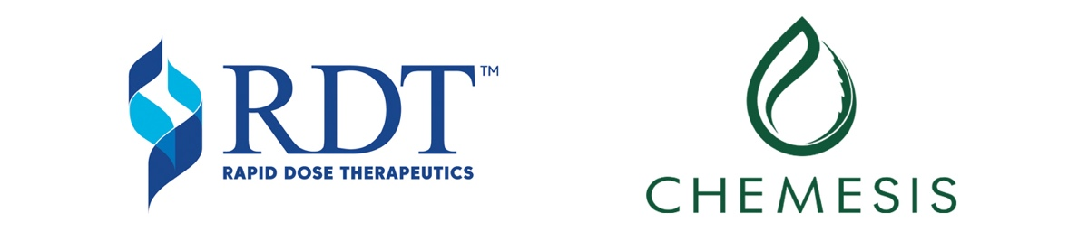

rapid dose therapeutics and CHemesis to introduce
innovative quickstrip™ oral thin strips
to the michigan cannabis market

Burlington, ON and Vancouver, BC, June 27, 2019 — Rapid Dose Therapeutics Corp. (CSE: DOSE), (“RDT”) and Chemesis International Inc. (CSE: CSI) (OTC: CADMF) (FRA: CWAA) (the “Company”) announced today that they have expanded the scope of their previously announced agreement (the “Agreement”) expanding the territory where Chemesis has been granted Gold Vendor Status to license, manufacture, distribute and sell RDT’s QuickStrip™ innovative, proprietary delivery technology for the medical cannabis market to Michigan, USA.

“We are focused and committed to providing consumers in the U.S. medical and recreational cannabis markets a Smoke-Free Choice™,” said Mark Upsdell, CEO of RDT. “RDT will continue to expand our strategic global partnerships and further strengthen our market share in the cannabis sector. This Agreement with Chemesis improves the QuickStrip™ position as a growing international brand and delivery device to Michigan consumers, while simultaneously offering health benefits and improving patient outcomes.”

RDT’s proprietary QuickStrip™ technology is a Quick, Convenient, Precise, Discreet™ oral fast-dissolving drug delivery system that offers a No Smoke, No Smell, No Stigma™ product to consumers. Chemesis expects to produce and distribute QuickStrip™ in Michigan by the end of 2019.

“Michigan is a lucrative and growing market in which we have recently received approval to produce quality cannabis products. Chemesis continues to take an aggressive growth approach to ensure a leading presence in the U.S. as the opportunities evolve,” said Edgar Montero, CEO. “Chemesis is committed to providing patients and consumers advanced cannabis products and innovations. This expanded agreement with RDT will enable us to bring QuickStrip™ technology to the Michigan market and offer patients a unique product that delivers a consistent and precise dosage.”

As part of the Agreement, Chemesis maintains the option to add future markets as the opportunity in those regions evolve.

About Rapid Dose Therapeutics
Rapid Dose Therapeutics Corp. is a publicly-traded Canadian life sciences company that provides innovative, proprietary drug delivery technologies designed to improve outcomes and quality of lives. RDT offers Quick, Convenient, Precise and Discreet™ choices to consumers. RDT is focused and committed to clinical research and product development for the healthcare manufacturing industry, including nutraceutical, pharmaceutical and cannabis industries. Within the cannabis sector, RDT provides a turn-key Managed Strip Service Program which enables RDT’s QuickStrip™ proprietary drug delivery technology to be licensed by select partners. RDT’s service based annuity contracts drive recurring revenue which enables rapid expansion into emerging markets — generating value for consumers and shareholders. Rapid Dose Therapeutics is committed to continually create innovative solutions aimed at multiple consumer segments and future market needs — including humans, animals and plants.

For more information, visit: www.rapid-dose.com
For inquiries please contact:
Mark Upsdell, CEO Ali Mahdavi, Managing Director
Rapid Dose Therapeutics Spinnaker Capital Markets Inc.
mupsdell@rapid-dose.com am@spinnakercmi.com
Office (416) 477-1052 Office (416) 962-3300

Social Media
RapidDoseTherapeutics.linkedin
RapidDoseTherapeutics.twitter
RapidDoseTherapeutics.facebook
QuickStrip.instagram

About Chemesis International Inc.

Chemesis International Inc. is a vertically integrated U.S. Multi-State operator with International operations in Puerto Rico, and Colombia.

The Company focuses on prudent capital allocation to ensure it maintains a first mover advantage as it enters new markets and is committed to differentiate itself by deploying resources in markets with major opportunities. The Company operates a portfolio of brands which cater to a wide community of cannabis consumers, with focus on quality and consistency.

Chemesis has facilities in both Puerto Rico and California, and is in the process of constructing a GMP certified facility in Colombia. Chemesis’ Puerto Rico operations are licensed to operate 100,000 ft² of cultivation, and 35,000 ft² of manufacturing floor space. The Company is positioned to win additional licenses in highly competitive merit-based US states, and will expand its footprint to ensure it maintains a first mover advantage.

Investor Relations:
ir@chemesis.com
1 (604) 398-3378

Social Media:
Chemesis.facebook
Chemesis.twitter
Chemesis.instagram
DesertZen.instagram
Jay&SB.instagram

CAUTIONARY NOTE REGARDING FORWARD-LOOKING STATEMENTS: Certain information in this news release may contain forward-looking information within the meaning of applicable securities laws. Any statements that are contained in this news release that are not statements of historical fact may be deemed to be forward- looking statements. Forward looking statements are often identified by terms such as “may”, “should”, “anticipate”, “expect”, “potential”, “believe”, “intend” or the negative of these terms and similar expressions. Statements containing forward-looking information, including, without limitation, in respect of the delivery of products using the QuickStrip™ product delivery method, express, as at the date of this news release, the plans, estimates, forecasts, projections, expectations or beliefs of RDT as to future events or results and are believed to be reasonable based on information currently available to them. Forward-looking statements necessarily involve known and unknown risks, including, without limitation, risks associated with general economic conditions; adverse industry events; marketing costs; loss of markets; future legislative and regulatory developments involving cannabis; inability to access sufficient capital from internal and external sources, and/or inability to access sufficient capital on favourable terms; the cannabis industry in Canada generally, income tax and regulatory matters; the ability to implement its business strategies; competition; currency and interest rate fluctuations and other risks. Readers are cautioned that the foregoing list is not exhaustive. There can be no assurance that statements of forward-looking information, although considered reasonable by management at the time of preparation, will prove to be accurate as there can be no assurance that the plans, intentions or expectations upon which they are based will occur. Actual results and future events could differ materially from those anticipated in such statements. Readers should not place undue reliance on forward-looking information. Forward-looking statements contained in this news release are expressly qualified by this cautionary statement.

