PODA LIFESTYLE AND WELLNESS PROVIDES CORPORATE UPDATE

Vancouver, BC, May 4, 2021 – PODA LIFESTYLE AND WELLNESS LTD. ("Poda Lifestyle" or the "Company") (CSE: PODA) is pleased to announce that the Company’s subordinate voting shares (“Common Shares”) have been approved for listing on the Canadian Securities Exchange (“CSE”). The Company’s shares will commence trading at market open on May 4, 2021 under the symbol ‘PODA’.

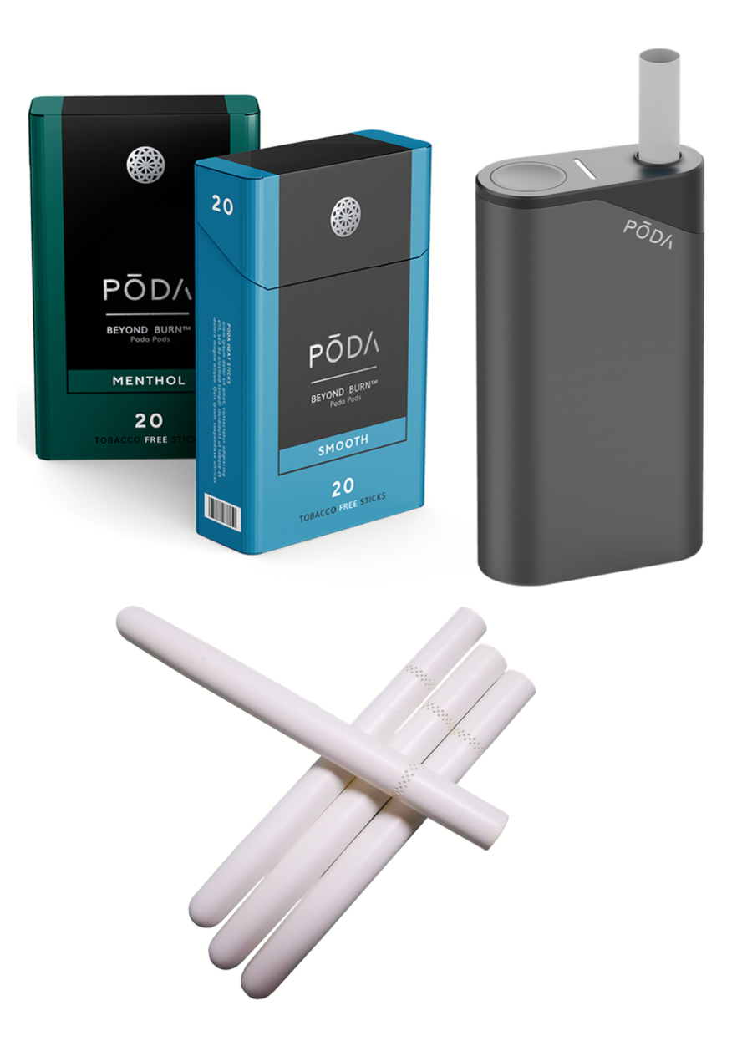

Additionally, the Company is pleased to provide the following operational update on agreements and other corporate matters:

Beyond Burn

The Company filed trademarks in Canada, US and Europe for Beyond Burn representing a new way to brand the multi-billion heat-not-burn (“HNB”) market. Poda Lifestyle is actively engaged in the global commercialization of HNB smoking products, which have the potential to reduce the risks associated with combustible smoking products. The Company has developed a patented HNB system that uses proprietary biodegradable single-use pods, which are both consumer and environmentally friendly. The innovative design of the Company’s HNB platform prevents cross-contamination between the heating devices and the pods, eliminating all cleaning requirements and providing users with the most convenient and enjoyable potentially-reduced-risk smoking experience. Poda Lifestyle’s HNB system is fully patented in Canada and is patent pending in 65 additional countries, covering over 70% of the global population. The Company’s Poda Pods are the first and only cigarettes to have a completely closed end. This exclusive design entirely eliminates all cleaning requirements and provides a truly ashless HNB cigarette. Poda Lifestyle’s fully-patented system is truly one of a kind and solves the major pain-point that all other HNB products suffer from: daily cleaning requirements. The Company’s flagship Beyond Burn™ Poda Pods contain a unique tobacco-free blend of pelletized tea leaves infused with synthetic nicotine, which provides adult smokers with a smoke-free alternative to their regular habit without sacrificing the satisfaction they are accustomed to. Beyond Burn™ Poda Pods have been expertly crafted to mimic the sensorial experience of traditional cigarettes without the smoke, without the smell, and without the tobacco.

Advisory Agreement

The Company executed an advisory agreement with Daniel Chen. Mr. Chen founded Shenzhen ESON Technologies Co. Ltd. (“ESON”) in 2010. ESON has designed numerous electronic nicotine delivery systems (“ENDS”) and has successfully licensed its IP to some of the biggest tobacco companies in the world. In addition, ESON has served as an original equipment manufacturer for some of the biggest tobacco companies globally, including Japan Tobacco International, Imperial, British American Tobacco, Godfrey Phillips India, Philip Morris International, and China National Tobacco. In 2020, Mr. Chen founded the NEAFS brand a non-tobacco synthetic nicotine blend that is IQOS compatible. Mr. Chen brings a wealth of valuable experience to the Poda team.

Letter of Intent for Joint Development Agreement

The Company executed a Binding Letter of Intent (“LOI”) with ESON. Within 60 days of the signing of the LOI, the Company and ESON have agreed to enter into a Joint Development Agreement (“JDA”) with the goal of commercializing a “NEAFS by PODA” product line to be sold through the ESON’s established distribution channels. If certain milestones of the JDA are met, both parties agree to pursue future partnership opportunities. NEAFS is currently selling over 50 million IQOS compatible NEAFS sticks per month into the Chinese and European markets and PODA plans on working with ESON’s distribution platform to launch NEAFS by PODA in 2021.

Debt Assignments

On March 30, 2020, the Company completed an assignment agreement whereby it assumed liabilities of Poda Tech totaling $2,445,721 and convertible debentures with a principal balance of $550,000 to Poda Lifestyle.

Beyond Burn Brand, Marketing, and Investor Relations Agreements

Poda Lifestyle is also pleased to announce the signing of an agreement with North Equities for a six-month term. North Equities will provide social media and client outreach strategy services for the Company.

Poda Lifestyle is also pleased to announce the signing of an agreement with Oil and Gas Corporate Bulletin (“OGIB”) for a six-month term. OGIB will provide digital marketing, publishing, and writing services. OGIB has no interest, direct or indirect, in the Company or its securities, or any right or interest to acquire such an interest.

Poda Lifestyle is also pleased to announce the signing of an agreement with Tanoy Digital Inc. (“Tanoy”) for a twelve-month term.

Poda Lifestyle is also pleased to announce commencement of an agreement with Aktiencheck.de AG for European Marketing Awareness.

Stock Options

The Company has also granted an aggregate 500,000 incentive stock options to certain officers, directors, and other eligible persons of the Company. The options are exercisable, subject to vesting provisions, over a twenty-four-month price of $0.10 per share.

On Behalf of the Board,
Ryan Selby
CEO, Director, and Chairman of the Board

Poda Lifestyle and Wellness Ltd.
Toll-free North America: +1-833-TRY-PODA (879-7632)
Outside North America: +1-406-TRY-PODA (879-7632)
investors@podalifestyle.com
www.podalifestyle.com

ABOUT PODA LIFESTYLE

Poda Lifestyle is actively engaged in the global commercialization of HNB smoking products, which have the potential to reduce the risks associated with combustible smoking products. The Company has developed a patented HNB system that uses proprietary biodegradable single-use pods, which are both consumer and environmentally friendly. The innovative design of the Company’s HNB platform prevents cross-contamination between the heating devices and the pods, eliminating all cleaning requirements and providing users with the most convenient and enjoyable potentially-reduced-risk smoking experience. Poda Lifestyle’s HNB system is fully patented in Canada and is patent pending in 65 additional countries, covering over 70% of the global population. The Company’s Poda Pods are the first and only cigarettes to have a completely closed end. This exclusive design entirely eliminates all cleaning requirements and provides a truly ashless HNB cigarette. Poda Lifestyle’s fully-patented system is truly one of a kind and solves the major pain-point that ALL other HNB products suffer from: daily cleaning requirements. The Company’s flagship Beyond Burn™ Poda Pods contain a unique tobacco-free blend of pelletized tea leaves infused with synthetic nicotine, which provides adult smokers with a smoke-free alternative to their regular habit without sacrificing the satisfaction they are accustomed to. Beyond Burn™ Poda Pods have been expertly crafted to mimic the sensorial experience of traditional cigarettes without the smoke, without the smell, and without the tobacco.

FORWARD-LOOKING STATEMENTS
This news release contains "forward-looking information" within the meaning of applicable securities laws. Although Poda Lifestyle believes in light of the experience of its officers and directors, current conditions and expected future developments and other factors that have been considered appropriate, that the expectations reflected in this forward-looking information are reasonable, undue reliance should not be placed on them because Poda Lifestyle can give no assurance that they will prove to be correct. Readers are cautioned to not place undue reliance on forward-looking information. Actual results and developments may differ materially from those contemplated by these statements. The statements in this press release are made as of the date of this release. Poda Lifestyle undertakes no obligation to comment on analyses, expectations or statements made by third-parties in respect of Poda Lifestyle, its securities, or financial or operating results (as applicable). Poda Lifestyle disclaims any intent or obligation to update publicly any forward-looking information, whether as a result of new information, future events or results or otherwise, other than as required by applicable securities laws.
The Canadian Securities Exchange has not reviewed and does not accept responsibility for the adequacy or accuracy of the content of this news release.

